Supplementary Material: All stimuli and data for this paper are available at Harvard Dataverse: https://dataverse.harvard.edu/dataset.xhtml?persistentId=doi:10.7910/DVN/QPNN86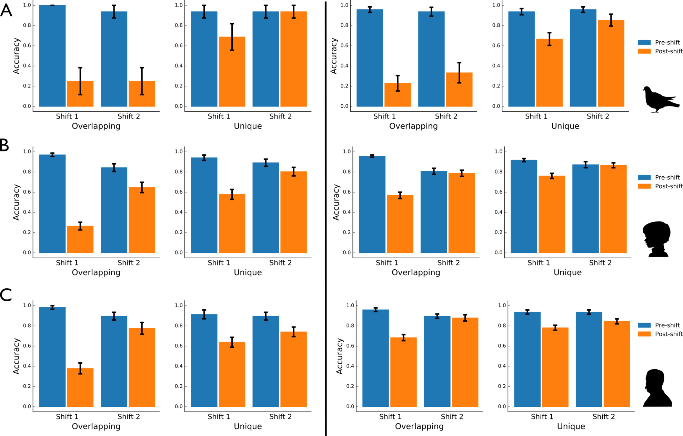
Figure S1: Pre- and post-shift accuracy for Experiment 1 (A), Experiment 2a (B), and Experiment 2b (C), calculated using 1 trial (left) and 3 trials (right). As explained in the main text, these data are included to examine the generality of our findings that were based on the analyses of five trials. As shown in the figure, the pattern of results reported in the main paper remained the same regardless of the number of trials analyzed.

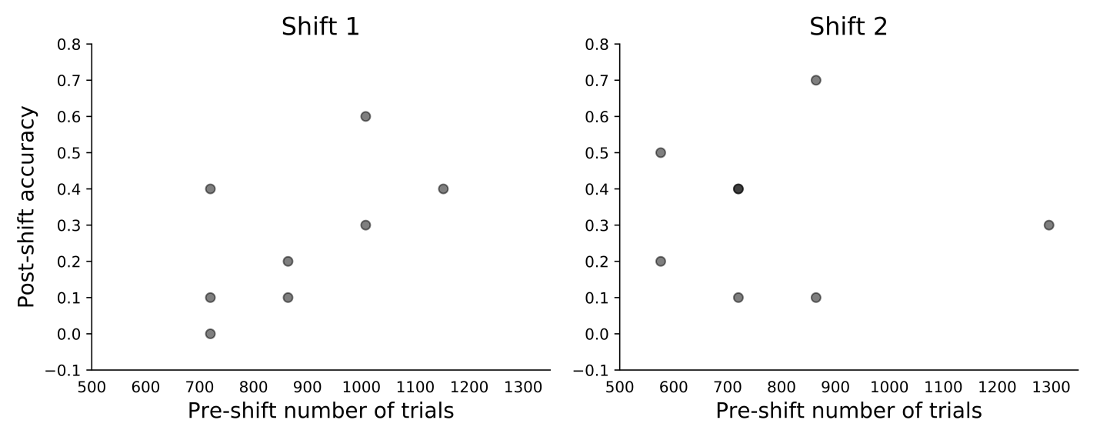
Figure S2: The relationship between the number of trials to criterion for the pre-shift phase and post-shift accuracy for overlapping pairs. This relationship was not significant for Shift 1, r(7) = .60, p = .12 or Shift 2, r(7) = -.02 p = .96. Note that if extensive training led to lower post-shift accuracy, then there should have been a negative correlation between these variables. 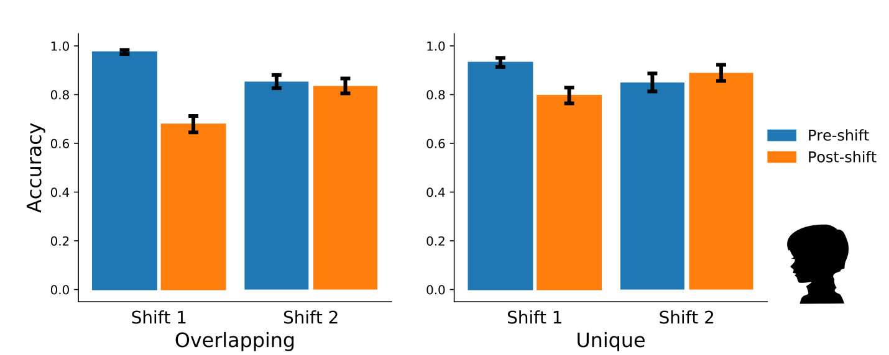

Figure S3: Accuracy before and after each shift for overlapping (left) and unique (right) pairs, for children with 85% or higher accuracy for overlapping trials in Phase 1. To compare this sub-sample (we refer to it as High Training Accuracy) with the remaining group, we conducted a 2 (Sample: High Training Accuracy vs. Rest) x 2 (Order: Shift 1 vs. Shift 2) x 2 (Shift: Pre-Shift vs. Post-Shift) x 2 (Pair Type: Overlapping vs. Unique) mixed ANOVA. The only significant effect was the pair type by sample interaction, F(1,49) = 9.05, p = .004, indicating that the participants with High Training Accuracy were more accurate than the Rest for the Overlapping, but not for the Unique pairs. No other main effects or interactions were significant, all ps > .16. We conclude therefore, that participants with High Training Accuracy were not more likely to exhibit perseverations after the shift.

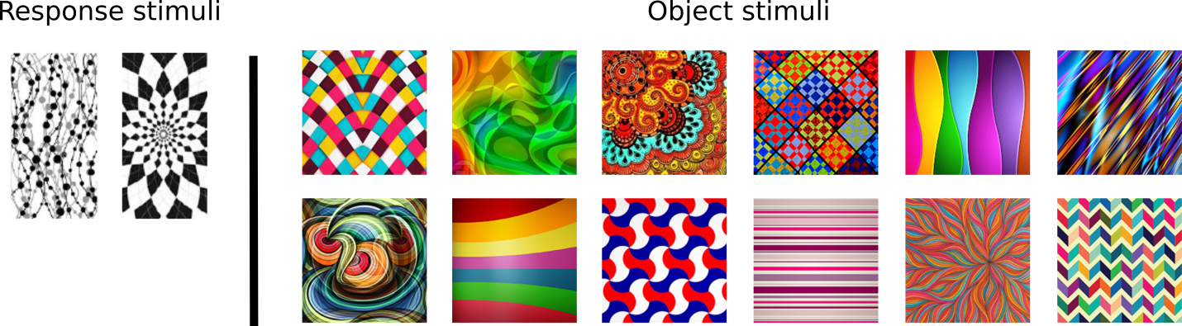
Figure S4: Abstract response stimuli (left) and object stimuli (right). These novel stimuli were used in an additional experiment with human adults to control for species differences in stimulus familiarity (see Fig. S5 for data analysis from this experiment).

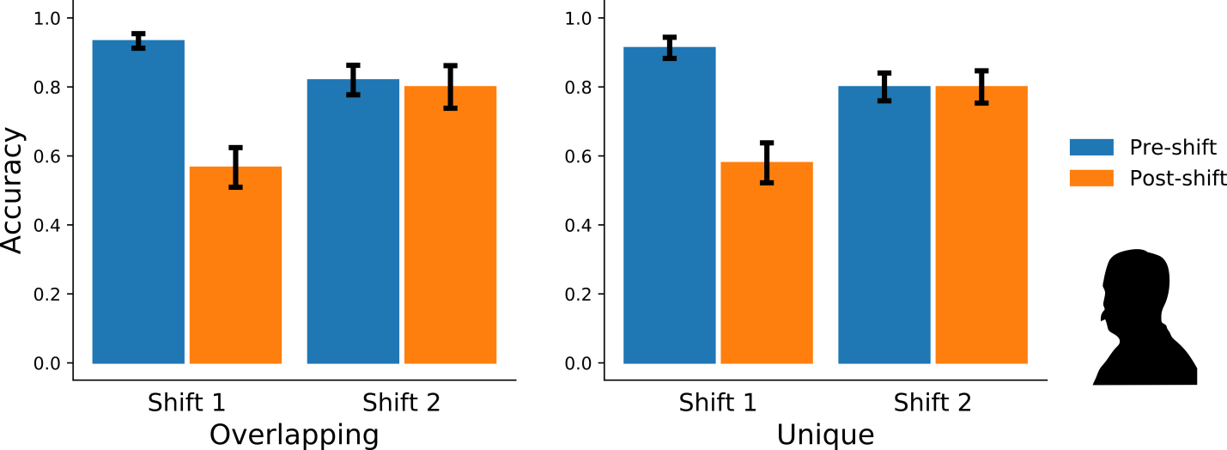
Figure S5: Adults’ accuracy for abstract stimulus contingencies before and after response shifts for overlapping (left) and unique (right) pairs.
Fifteen out of 30 adults met the inclusion criteria used for Experiment 2b. This is proportionally a marked decrease from Experiment 2b, in which familiar, nameable stimuli were used, suggesting that the task was more difficult to learn with abstract stimuli. The following analyses were performed with only the 15 adults who met the inclusion criteria, but the pattern of results is very similar when analyzing the whole sample regardless of performance.
Recall that adults demonstrated cognitive flexibility in Experiment 2b, with no drop in performance for overlapping pairs following the second response shift (M_{decrease} = .01, SD = .14, p = .69), and above-chance accuracy following the same shift, M_{accuracy} = .89, SD = .13), t(28) = 16.32, p < .001, CI_{accuracy} [.84, .94], d = 3.03, CI_{d} [2.16, 3.90]. In the Control Experiment, adults demonstrated the same pattern of results with abstract novel stimuli. A paired-samples t-test revealed that, as in Experiment 2b, there was no significant drop in performance for overlapping pairs following the second shift in the abstract stimulus experiment, p = .66. In addition, accuracy for overlapping pairs was above chance following the second shift (M_{accuracy} = .80, SD = .24), t(14) = 4.86, p < .001, 95% CI_{accuracy} [.67, .93], d = 1.26, CI_{d} [0.56, 1.93]. This pattern of results suggests that abstract stimuli had little effect on cognitive flexibility (although they were more difficult to learn, but they): similar to familiar stimuli, there was no drop in performance following the second shift.

